AIR QUALITY ANALYSIS IN TAMILNADU

PROBLEM DEFINITION:

Air quality is linked to human activities, earth’s climate and ecosystems globally. Many of the drivers of air pollution (i.e. combustion of fossil fuels) are also sources of CO2 emissions and other short-lived climate pollutants,

such as ozone and black carbon that greatly contribute to climate change, and affect human health.

DESIGN THINKING:

With the rapid development of economy and the frequent occurrence of air pollution incidents, the problem of air pollution has become a hot issue of concern to the whole people. The air quality big data is generally characterized by multi-source heterogeneity, dynamic mutability, and spatial–temporal correlation, which usually uses big data technology for air quality analysis after data fusion.

ANALYSIS OBJECTIVES:

The primary necessity for sustaining human health and that of the supporting ecosystems, which in turn affects human wellbeing, is clean air. We have seen significantly increased concentrations of air pollutants due to the economy's rapid expansion, the consumption of fossil fuels, and a lack of emission restrictions. These pollutants not only worsen regional air quality but also have a considerable negative influence on human health and the climate.

DATA COLLECTION:

Indian city name where air quality is measured

Date: The date that the air quality was measured, in the format DD-MM-YYYY.

Aqi: Air Quality Index, a number that reflects the general level of air quality at a particular place and time.

The pollutants in the following columns are all measured in g/m3.

Carbon monoxide (CO) is a colorless, odorless gas that results from the incomplete combustion of biomass and fossil fuels.

NO: Nitric oxide, a dangerous gas released during the combustion of fossil fuels and during industrial operations.

Nitrogen dioxide (NO2) is a dangerous gas that is primarily released during combustion processes and when vehicles are in motion.

When sunlight interacts with contaminants like nitrogen oxides and volatile organic compounds, ozone, or O3, is created.

VISUALIZATION STRATEGY:

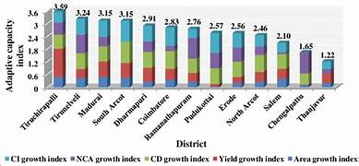

Air quality visualization is nothing but the graphical representation of data. Which will help us to understand

the distributions of air pollutants in the atmosphere.